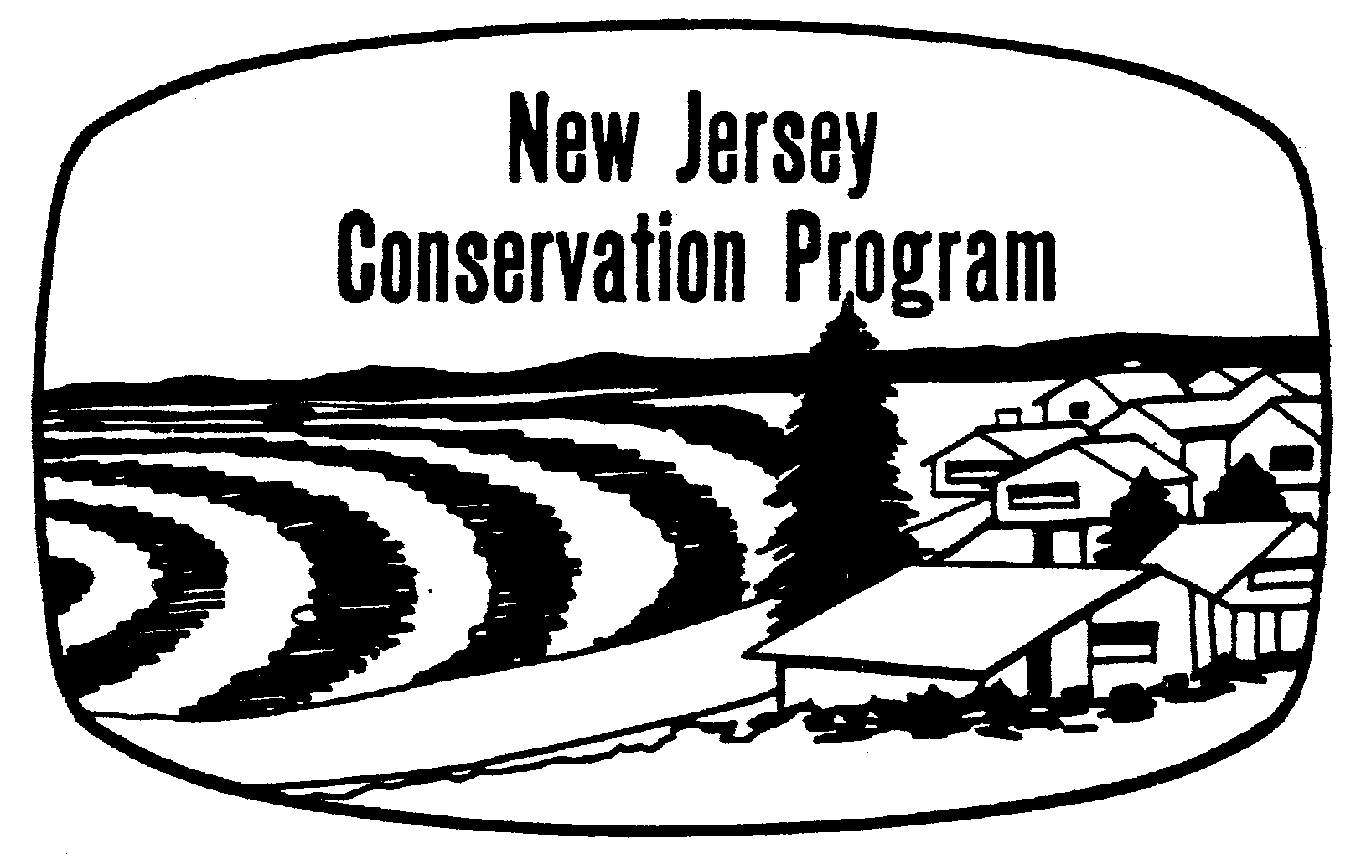

**CONSERVATION AGREEMENT**

I request assistance to address the natural resource concerns indicated on the reverse side of this form for the property identified as:

Block: _____ Lot: _____ Municipality: ____________________ Acres: _____

Location/Address: _______________________________________________________

I agree to enter into this agreement to plan for the wise use and conservation treatment of the natural resources under my control. I agree to utilize the technical assistance provided and participate in the development of a Conservation Plan based on the capabilities of the land and needs of my agricultural enterprise; to apply the practices in the Conservation Plan to the best of my ability; and to maintain the practices for their intended purpose and lifespan.

I further agree to cooperate with the Soil Conservation District (SCD) and/or USDA Natural Resources Conservation Service (NRCS) employees, who may enter upon my property for the purposes of planning, applying, or checking the conservation practices in my Conservation Plan. I also agree that SCD, NRCS, or any of their partners shall not be held liable for damages resulting from implementation or failure to properly implement conservation practices in my Conservation Plan.

This agreement will remain in effect until terminated in writing by either party.

Applicant: _______________________________ Property Owner: ______________________

IF OTHER THAN APPLICANT

Address: ________________________________ Address: ____________________________

________________________________ ____________________________

Telephone: Home___________________________ Cell______________________________

____________________________ __________ ______________________ ____________

APPLICANT SIGNATURE DATE OWNER SIGNATURE DATE

**:::::::::::::::::::::::::::::::::::::::::::::::::::::::::::::::::::::::::::::::::::::::::::::::::::::::::::::::::::::::::::::::::::::::::::::::::::::::::::::::::::::::::::::::**

The___Hudson/Essex/Passaic________ COUNTY SOIL CONSERVATION DISTRICT (SCD) Board of Supervisors agrees to accept the Applicant as a District Cooperator and provide assistance in accordance with the District’s policies and objectives, subject to the availability of technical assistance from the SCD, USDA Natural Resources Conservation Service, or other cooperating partner agencies.

___________________________ _______________________

DISTRICT CHAIRPERSON  DATE

Assistance to be provided by:  SCD  NRCS Priority: High  Medium    Low 

**NATURAL RESOURCE CONSERVATION ASSISTANCE IS NEEDED FOR:**

CHECK ALL NEEDS or CONCERNS

❑ Erosion Control  Surface Water Control  Sedimentation Reduction

❑ Farmland Preservation  Cropland Protection/Production  Agricultural Waste Mgt.

❑ Grassland Management  Grazing System Planning  Forest Management

❑ Irrigation System Mgt.  Endangered Species  Wildlife Management

❑ Invasive Plants  Soil Compaction  Soil Health  

❑ Conservation Plan  Nutrient Management Plan  Organic Farming

❑ Other concerns: ______________________________________________________________ ______________________________________________________________________________

______________________________________________________________________________

______________________________________________________________________________

______________________________________________________________________________

______________________________________________________________________________

**LAND USE:**

|  |  |  |  |  |  |  |  |  |
| --- | --- | --- | --- | --- | --- | --- | --- | --- |
|  | Cropland | Hayland | Pasture | Grassland | Forest | Farmstead |  | TOTAL |
| Acres Owned |  |  |  |  |  |  |  |  |
| Acres Rented |  |  |  |  |  |  |  |  |

**LIVESTOCK:**

|  |  |  |  |  |  |  |  |  |
| --- | --- | --- | --- | --- | --- | --- | --- | --- |
|  | Dairy | Beef | Sheep | Horses | Goats | Hogs | Chickens |  |
| Number |  |  |  |  |  |  |  |  |

Mail to: Hudson-Essex-Passaic County Soil Conservation District

15 Bloomfield Ave

North Caldwell, NJ 07006

Phone: 973-364-0786

Fax: 973-364-0784